**2021-09-07**

NEW IDEA PROPOSAL FOR AMPS

**Presented by**

Er. Prem Bashyal**「**Electronics Engineer**」**

Team Name: Nudge Solutions

Email: [bashyal.prem@nudge-solutions.com](mailto:bashyal.prem@nudge-solutions.com)

Account Name: [KazuoS.@satecLTD](mailto:KazuoS.@satecLTD)

Account ID: support@nudge-solutions.com

Phone No: 81+ 80-4581-9318

URL: https://nudge-solutions.com/

YOKOHAMA, JAPAN

September 07, 2021

**INTRODUCTION TO AMPS SOLUTION**

The main aim of the project is to maintain the automatic system in the Protection system. AMPS challenge supports the comprehensive testing of the existing protection system. The system includes the Protective relays, Instrument transformer, Revenue meter and the Microprocessor. As the main purpose of the challenge is to automate the existing protection system, after the completion of the project it reduces the labour requirement to complete testing.

At first, I did detailed research on the device used in the system. After the research I came to know about the applications of devices and the way of controlling them in the system. Microprocessor based relay, Revenue meter, Instrument Transformer, Microprocessor are the main devices used in the AMPS system. After knowing the way of controlling them I developed the Circuit diagram of the system using Serial communication and Ether communication.

From the Circuit diagram it gives a clear idea of methods of interfacing the devices. Also, the flow of the information/data between the devices were studied during the Circuit design Development.

After Completion of the Circuit design, I developed the Software Part for controlling the system. Controlling the System in Software development starts from the development of flowchart of three different phases. I developed the Phase control flowchart which includes the control over different phases that undergoes in the system with controlling the Relay. Also, the further phases include the ways to control relay and test that should be done during the system development.

Software diagram gives a clear vision of the Software function operated in the system. The flow of software functions to control the whole system is explained in the Task Configuration diagram. Also, I did the additional survey on the devices and the terms that help for the development of Automotive maintenance of the protective system.

Thus, till now I came to know about the hardware schematics of the AMPS and the Software function that should be followed for the final development. Hence, Automotive maintenance of protective systems can be developed Using SEL relays, Instrument Transformers, Revenue meter, Microprocessor. I am looking forward to the development of the Prototype Challenge in AMPS.

Thank you.

**TABLE OF CONTENTS**

1 overview 1

1.1 DESCRIPTION ON PROTECTION SYSTEM 3

1.2 AMPS SOLUTIONS 7

1.3 BURDEN MEASUREMENTS IN AMPS 8

2 Hardware schematics in AMPS 10

2.1 SERIAL INTERFACING CIRCUIT IN AMPS 10

2.2 ETHERNET INTERFACING CIRCUIT IN AMPS 11

2.3 SERIAL BLOCK DIAGRAM IN AMPS 12

2.4 ETHERNET BLOCK DIAGRAM IN AMPS 13

3 Software block in AMPS 14

3.1 PHASE CONTROL FLOWCHART 14

3.2 RELAY CONTROL FLOWCHART 15

3.3 TEST PHASE FLOWCHART 16

3.4 SOFTWARE DIAGRAM IN AMPS 17

3.5 AMPS SOFTWARE FUNCTION LISTS 18

3.6 TASK CONFIGURATION DIAGRAM IN AMPS 30

3.7 AMPS TASK CONFIGURATION LIST 31

4 Additional survey on AMPS 34

4.1 DEVICES AND TERMS USED IN AMPS 34

**4.1.1 Transformer 34**

**4.1.2 Current transformer 38**

**4.1.3 Potential transformer 40**

**4.1.4 Wattmeter 41**

**4.1.5 Voltmeter and Ammeter 42**

**4.1.6 Self-Induction and Negative Voltage 44**

4.2 RELAY WORKING PRINCIPLE 47

4.3 PROTECTIVE RELAY 48

4.4 INTERFACING RELAY WITH MICROPROCESSOR 51

4.5 INTERFACING CIRCUIT OF RELAY WITH MICROPROCESSOR 53

4.6 BACnet COMMUNICATION PROTOCOL 56

**4.6.1 BACnet Features 57**

**4.6.2 BACnet Applications 58**

**4.6.3 BACnet Network Types and Architecture 59**

4.7 THREE PHASE AC POWER 61

**4.7.1 SINGLE-PHASE AC POWER SUPPLY 61**

**4.7.2 THREE-PHASE AC POWER SUPPLY 63**

**4.7.3 BALANCED THREE PHASE CIRCUIT 65**

**4.7.4 Y-Y CONNECTION THREE PHASE CIRCUIT 66**

**4.7.5 Δ-Δ CONNECTION THREE PHASE CIRCUIT 66**

**4.7.6 V- Δ CONNECTION THREE PHASE CIRCUIT 67**

**4.7.7 Δ -Y/ Y- Δ CONVERSION LOAD CIRCUIT 68**

4.8 LINEAR POWER GENERATOR 69

4.9 SERIAL/ETHERNET BOUND RATE AND MIPS 72

4.10 REAL TIME LINUX OPERATING SYSTEM 74

5 Conclusion 76

# **overview**

1. Power systems mainly depend upon the protective relays to monitor critical electrical quantities and initiate emergency shutdown on the detection of out-of-limit conditions.
2. Instrument transformers, such as potential transformers (PT) and current transformers (CT), reduce the power system currents and voltages to levels usable by protective relays and other control and metering devices.
3. Instrument transformers for metering purposes must have a high degree of accuracy to ensure precise billing while those used for protection must react correctly during fault events.
4. Protective relays are an essential component of the protection system of a power system; they monitor critical electrical quantities and initiate emergency shutdown when they detect out-of-limit conditions.
5. The relays must correctly detect abnormal conditions, shut down the appropriate equipment, and must not operate incorrectly or unnecessarily.
6. All relay settings must be kept up to date and any changes must be documented and verified.

## **DESCRIPTION ON PROTECTION SYSTEM**



Fig 1.0: General diagram of Protection system

**Essential to protecting:**

1. Powerplant and switchyard equipment and system.
2. The electric power system.

**Perform coordinated tripping activities**

1. Improves safety to the employees
2. Reduces damage to equipment
3. Ensures reliability of the grid

**Protection system equipment**

1. Instrument Transformers
2. Protective Relays
3. Lockout Relays
4. Circuit Breakers
5. **Instrument Transformers**

* System currents and voltages are too high to use directly in the protection equipment.
* So, the magnitude of currents and voltages should be lower down using instrument transformers.

1. Current Transformers

* Reduces the current values of the system.
* i.e., reduces current from 6000 amps to 5 amps.

1. Potential Transformers

* Reduces the voltage values of the system.
* i.e., reduces voltage from 13,800 volts to 69 volts or 120 volts.

1. **Protective relays**

* It utilizes the signals from instrument transformers to determine proper state of operation.
* For example, if overcurrent situations occur in the system, Relay itself picks up a contact and initiates the tripping action for the protection of the system.
* If we utilize Electromechanical or Solid-state Relays, we must have one relay box for each protective element.
* However, in the case of microprocessor-based relays we can corporate 20-30 Electromechanical Relays in one box.

1. **Lockout Relays**

* Once protective relay initiates the trip coil, the function of Lockout Relays starts.
* Lockout relays combine the signals from multiple protective relays and initiate the tripping of the circuit breaker to remove the harmful energy from the system where the fault may occur.

1. **Circuit Breakers**

* It interrupts current flow after an event on the electrical grid to protect employees and equipment.
* From the start to finish, a protective system should sense the misoperation and open the circuit breaker in less than 0.1667 seconds.

**Protection Systems testing**

* Must require the plant equipment to be offline.
* Maintenance task:

1. Setting Verifications of the protective relays.
2. Verification of currents transformers (CT) and potential transformer (PT) signals at the protective relay.
3. Measurement and recording of CT and PT burden measurements.
4. Verification of analog to digital converters at protective relays are metering and working correctly.

**Physical locations of protection systems**

1. Instrument Transformer

* Typically located at or near equipment like Generator, transformer etc.
* It can be challenging to access the instrument transformers based on the configuration of the equipment.

1. Protective Relays

* It can be located near the equipment but, more typically, is installed in a control room.
* The distance of the Protective relay from the instrument transformer can be several hundred feet away.

1. Power facilities in general

* Wireless communication is not ideal for the system.

## **AMPS SOLUTIONS**

**Required Solutions of AMPS**

1. Solution must verify the Relay setting whether the setting is correct or not via Online test method.
2. Verification of relay analog to digital inputs.
3. Verification of PT and CT signals at the relay.
4. Solution must work with SEL relays and meters.
5. Must produce an alarm during the presence of default in the system.

**Additional solutions on AMPS**

1. Solution could have options of download and store relay event files.
2. Measure and store CTs/PTs burdens.
3. Working with manufactures relays and power meters.
4. Provide interfacing options with network or internet-based systems.
5. Address CT/PT tests.

# 

## **BURDEN MEASUREMENTS IN AMPS**

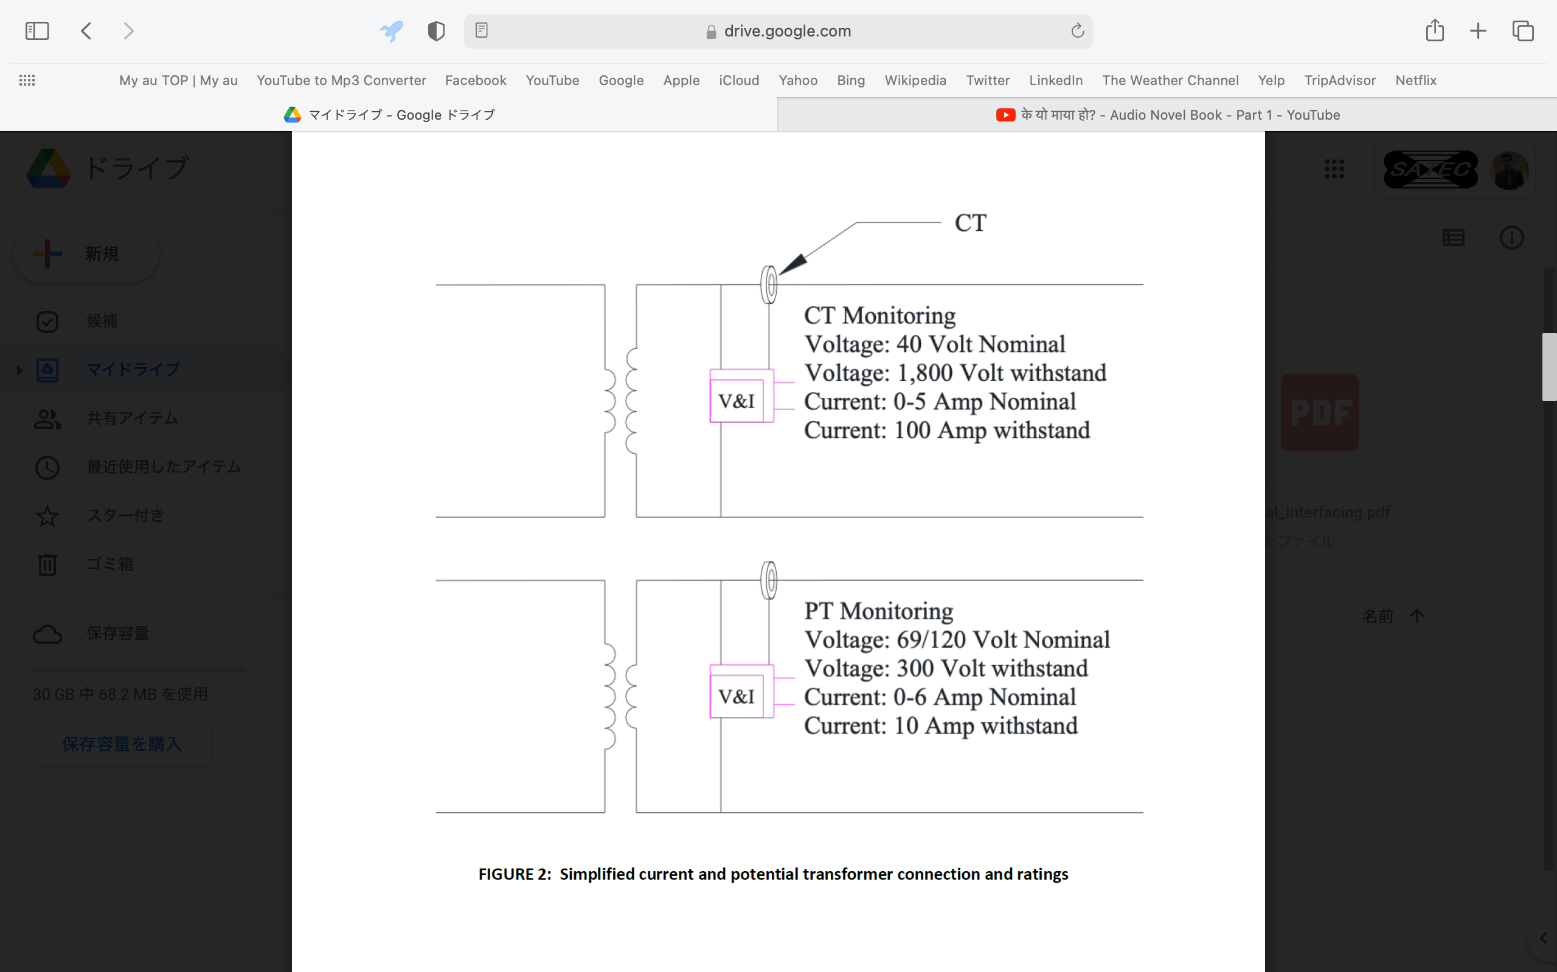Fig 1.1: Simplified Current and Potential transformer Connections and Ratings

1. Measure the voltage, current, and their resulting phase angle to calculate the burden.
2. Record both raw values as well as the calculated values back to a centralized piece of equipment.
3. Produce an alarm if values are not acceptable.

**Conformation of Relay working**

1. Signals will be received from the instrument transformer to the Relay.
2. Comparison of at least 2 relays is done. If there are different results in between two relays, there is an issue in a protection system.
3. Identifying the relay with issues will be easier if we compare the values of 3 or more relays.
4. Current and voltage magnitude and phase angles of different relays are compared with each other to conform the proper functioning of the relay.

**Comparison of the Relay for the Accuracy of the system**

1. By using the simple ASCII commands, data can be collected from the Relay.
2. Phase A, B and C current magnitude and phase angle is collected from the relay.
3. Phase A, B and C voltage magnitude and phase angle is collected from the relay.
4. Further data can be parsed to capture the required magnitude and phase angles.
5. This parsed data can then be compared to data read from other Relays.

# **Hardware schematics in AMPS**

## **SERIAL INTERFACING CIRCUIT IN AMPS**



Fig 1.2: Serial interfacing circuit

## **ETHERNET INTERFACING CIRCUIT IN AMPS**



Fig 1.3: Ethernet interfacing circuit

## **SERIAL BLOCK DIAGRAM IN AMPS**



Fig 1.4: Serial block diagram in AMPS

## **ETHERNET BLOCK DIAGRAM IN AMPS**



Fig 1.5: Ethernet block diagram in AMPS

# **Software block in AMPS**

## **PHASE CONTROL FLOWCHART**



## **RELAY CONTROL FLOWCHART**



## **TEST PHASE FLOWCHART**



## **SOFTWARE DIAGRAM IN AMPS**



Fig 1.6: Software block diagram in AMPS

## **AMPS SOFTWARE FUNCTION LISTS**

1. Application layer

**A1. Core Application Server**

1. An application server is a mixed framework of software that allows both the creation of web applications and a server environment to run them.
2. An application server is designed to install, operate and host applications and associated services for end users, IT services and organizations and facilitates the hosting and delivery of high-end consumer or business applications.
3. AMPS includes the Core Application server so that Relay settings can be downloaded by the user from the relay. Download and store relay event files.
4. Also, users can use the provided interface options with a network connected computer or internet-based system.
5. Middle layer

B1. Self-Monitoring

1. AMPS supports the self-monitoring features.
2. Self-monitoring is the condition monitoring which is used to read the relay status on the regular basis (timer control) and send (display data) to the external display device by Ethernet communication.
3. Self-test mechanisms measure and verify that power supply voltages are within range, validate checksums of data.
4. It ensures that analog-to-digital conversion is correct and monitors watchdog timers.
5. Self-monitoring and self-testing support following features:

* Monitor digital relay self-test alarm contacts.
* Monitor digital relay loss-of-signal alarms.
* Use relay output control functions to verify output contacts.
* Compare relay meter readings to other meters to verify calibration of both devices.

B2. Digital output/alarm

1. Digital output value of the Protective Relay and Revenue meter is continuously monitored by the Microprocessor.
2. Self-monitoring always confirms that the incoming signals are within the tolerance range or not.
3. If the signals are not within the range, then the system produces the alarm.
4. The value of voltage (V) and current (I) must be within the tolerance range otherwise an alarm will be produced.
5. For Current Transformer (C.T)

|  |  |  |
| --- | --- | --- |
| Current Transformer | Nominal Value | Withstand Value |
| Voltage (V) | 40 Volt | 1800 Volt |
| Current (I) | * 1. Amp | 100 Amp |

1. For Potential Transformer (P.T)

|  |  |  |
| --- | --- | --- |
| Potential Transformer | Nominal Value | Withstand Value |
| Voltage (V) | 69/120 Volt | 300 Volt |
| Current (I) | * 1. Amp | 1. Amp |

B3. FTP Data File

1. The AMPS system contains the FTP data file supporting the FTP communication protocol.
2. File Transfer Protocol (FTP) is a standard [communication protocol](https://en.wikipedia.org/wiki/Communication_protocol" \o "Communication protocol) used for the transfer of [computer files](https://en.wikipedia.org/wiki/Computer_file" \o "Computer file) from a server to a client on a [computer network](https://en.wikipedia.org/wiki/Computer_network" \o "Computer network).
3. As SEL relays have a browser function Secure Socket Shell (SSH) is required for the security system.
4. Secure Socket Shell is a network communication protocol that enables two computers to communicate (http or hypertext transfer protocol, which is the protocol used to transfer hypertext such as web pages) and share data.
5. An inherent feature of SSH is that the communication between the two computers is encrypted meaning that it is suitable for use on insecure networks.
6. SEL relays also support the Hypertext Transfer Protocol (HTTP).
7. It is an application layer protocol for transmitting hypermedia documents, such as HTML. It was designed for communication between web browsers and web servers, but it can also be used for other purposes.
8. HTTP is a stateless protocol, meaning that the server does not keep any data (state) between two requests.

B4. Relay settings

1. Users must verify and record Relay settings on SEL relays and alarm on change.
2. The verification of SEL settings can be done through the Online test methods.
3. Online test method is used to download and compare the settings within a relay to save default settings.
4. If any settings have changed, the test must produce an alarm and highlight which settings do not match.
5. Additional corrective maintenance would then need to be performed to determine the source of the error.
6. When relay settings have been verified, apply “last tested” stickers to the front of the relay. These stickers should include the date of the last test and the initials of the person verifying the settings and calibration.

　　　　B5.　Relay control function

1. Relay function can be controlled by the Command packet of the Serial/Ethernet Communication.
2. High/low status of the digital I/O port defines whether the Relay is on or off.
3. The default settings for the serial port/Ethernet are the following:

**Serial Port:**

Baud Rate = 2400 BPS

Data Bits = 8

Parity = N

Stop Bits = 1

**Ethernet Port:**

Baud Rate = 100 MBPS

1. To change the port settings, we use the serial port **SET P n** command.
2. If the value of n in port p is high (i.e., 1) then the Relay remains in ON condition whereas the value of n is low (i.e., 0) means Relay is in off condition.

B6. Power monitoring function

1. AMPS system supports the Power monitoring function to support energy-saving activities.
2. These Power Monitoring Devices are mounted in facilities and equipment to take measurements.
3. Hence by taking the continuous measurement of Power in the system, we can monitor the desirable amount of power supplied in the system or not.
4. If thus monitored power is out of the tolerance, then the system must produce an alarm.
5. The rated current value of the Power monitoring function is as follows:

|  |  |
| --- | --- |
| **Rated Current** | **Section** |
| 1 Amp | ANSI class 2 |
| 5 Amp | ANSI class 10 |
| 10 Amp | ANSI class 20 |

|  |  |
| --- | --- |
| **Starting Current** | **Burden** |
| 0.002 Amp | 0.5 VA maximum |

1. Operating system layer

C1. Operating system

1. Operating system controls the Data transfer between the middle layer and the driver layer for each function.
2. **Embedded Linux** is used as an operating system to control all the operations of the system.
3. Linux is the [operating system](https://www.computerhope.com/jargon/o/os.htm) of choice for many [embedded systems](https://www.computerhope.com/jargon/e/embedded.htm) due to its low cost and easy customization.
4. Linux may require more [system resources](https://www.computerhope.com/jargon/r/resource.htm) than some other embedded operating systems but has a highly-tested stable kernel, is completely [open source](https://www.computerhope.com/jargon/o/opensour.htm) code, and a zero distribution cost.
5. Linux system is used to manage various services such as process scheduling, application scheduling, basic peripheral devices, file system, and more. So, as it can be used to develop the automotive maintenance of protection. System.
6. It supports almost all of the most used programming languages such as [C](https://www.javatpoint.com/c-programming-language-tutorial)/[C++](https://www.javatpoint.com/cpp-tutorial), [Java](https://www.javatpoint.com/java-tutorial), [Python](https://www.javatpoint.com/python-tutorial), [Ruby](https://www.javatpoint.com/ruby-tutorial), and more. Further, it offers a vast range of useful applications for development. We are using the Java programming language in the AMPS system.
7. The Linux operating system also provides support for SSH, which helps in managing the servers quickly.
8. Driver layer

* It consists of only one function to receive (input) or send (output) a signal according to the instruction command of the Operating system.
* Thus, the receive (input) data or send (output) data is copied by the Operating system from the middle layer to the driver layer respectively.
* Operating system uses the **COPY m n** command to copy the data from group m to group n.
* Driver layer consists of following mentioned parts:
  1. Digital driver (Digital I/O)
  2. Analog driver
  3. Power control system driver (PMC)
  4. Communication driver (Serial, TCP/IP)
  5. File System (HDD, FAT, NAND)
  6. 4.6 File System

**File System:**

* **File systems** provide efficient access to the disk by allowing data to be stored, located, and retrieved in a convenient way.
* Saving /retrieving setting values and saving/retrieving FTP data are primary functions of the file system.
* Without a file system, stored information wouldn't be isolated into individual files and would be difficult to identify and retrieve.
* File system always copies the file back into memory when we want to use it again, we can fetch a particular document from our file cabinet. This is known as retrieving data or opening a file.
* Most of the Operating Systems use a layering approach for every task including file systems.



* When an application program asks for a file, the first request is directed to the logical file system. The logical file system contains the Metadata of the file and directory structure.
* Generally, files are divided into various logical blocks. Files are to be stored in the hard disk and to be retrieved from the hard disk. Hard disk is divided into various tracks and sectors.
* Therefore, to store and retrieve the files, the logical blocks need to be mapped to physical blocks. This mapping is done by the File organization module. It is also responsible for free space management.
* Once File organization module decides which physical block the application program needs, it passes this information to the basic file system. The basic file system is responsible for issuing the commands to I/O control to fetch those blocks.
* I/O controls contain the codes by which it can access the hard disk. These codes are known as device drivers.

1. Java Virtual Machine Function
2. **Java Virtual Machine (JVM)** two primary functions: to allow Java programs to run on any device or operating system and to manage and optimize program memory.
3. **Java Virtual Machine (JVM)** is an engine that provides runtime environment to drive the Java Code or applications.
4. It converts Java bytecode into machine language.
5. A Java virtual machine can either interpret the bytecode one instruction at a time (mapping it to a real processor instruction) or the bytecode can be compiled further for the real processor using what is called a [just-in-time compiler](https://www.theserverside.com/definition/just-in-time-compiler-JIT).
6. In other programming languages, the compiler produces machine code for a particular system. However, the Java compiler produces code for a Virtual Machine known as Java Virtual Machine.



Fig: Working of JVM

1. First, Java code is compiled into bytecode. This bytecode gets interpreted on different machines.
2. Between the host system and Java source, Bytecode is an intermediary language.
3. JVM architecture in Java contains class loader, memory area, execution engine etc.
4. JIT stands for Just-in-time compiler. JIT is the part of the Java Virtual Machine (JVM). It is used to speed up the execution time.
5. Java applications are called WORA (Write Once Run Anywhere). This means a programmer can develop Java code on one system and can expect it to run on any other Java-enabled system without any adjustment. This is all possible because of JVM.

## **TASK CONFIGURATION DIAGRAM IN AMPS**



Fig 1.7: Task Configuration block diagram in AMPS

## **AMPS TASK CONFIGURATION LIST**

|  |  |  |  |
| --- | --- | --- | --- |
| **Task** | **Input data** | **Processing** | **Output data** |
| **1. Clock timer controlling task** | Clock signal | Interrupt the Processor after a specific period of time ensuring that function is completed in a given time Interval. | Clock signal |
| **2. Self monitoring task** | Serial/Ethernet data | Continuously monitors whether the data are within the range or not. | Monitored Serial/Ethernet data |
| **3. File system control task** | Serial/Ethernet data, Character data | It allocates space in a granular manner, usually multiple physical units on the device. Also, responsible for organizing files and directories. | File |
| **4. Client management task** | FTP data | It assigns the client request with a unique ephemeral port number, so multiple clients also have the unique connection. | Assigned FTP data |
| **5. D/A Conversion task** | Digital signal | Converts the digital signal to analog signal. | Analog signal |
| **6. Display control task** | Digital pulse data | Adds the corresponding digital bits to generate the analog value at its output. | Analog display data |
| **7. VM control task** | Analog display data | It sets the display via Browser (Web Server) | Analog display data |
| **8. Web connection tak** | FTP data | It connects your system to the Internet via a unique IP address. | Connection established between the system and Web. |
| **9. Alarm alert task** | Self-Monitoring | Continuously monitors the data and produces an alarm if the data aren’t within the range. | I/O data (Alarm signal) |
| **10. SSH Connection management task** | TCP/IP request data from client | Allows a requesting device to connect with the Server for information or services. The server has a designated TCP port over which it monitors the network, waiting for clients to initialize the connection. | Established Connection between the Client and Server. |
| **11. Security management task** | Character data | It established the Login ID and Password for maintaining the Security from unauthorised Users. | Login ID and Password |
| **12. Data transfer task** | Serial/Ethernet data | Transfers the Serial data using RS-232 protocol and transfer Ethernet data through RJ-45 ethernet cable. | Serial/Ethernet data |
| **13. Phase Control task** | Digital I/O port data | It switches the phases of the SEL relay. | Digital I/O data. |

# **Additional survey on AMPS**

## **DEVICES AND TERMS USED IN AMPS**

### Transformer

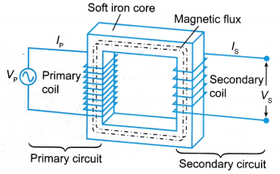

Fig 1.8: Transformer

Working Principle of Transformer

|  |  |
| --- | --- |
| 1 | A transformer operates on the principals of “electromagnetic  induction”, in the form of Mutual Induction. |
| 2 | Mutual induction is the process by which a coil of wire magnetically induces a voltage into another coil located near it. |
| 3 | Transformers are capable of either increasing or decreasing the voltage and current levels of their supply. |

Step up transformer

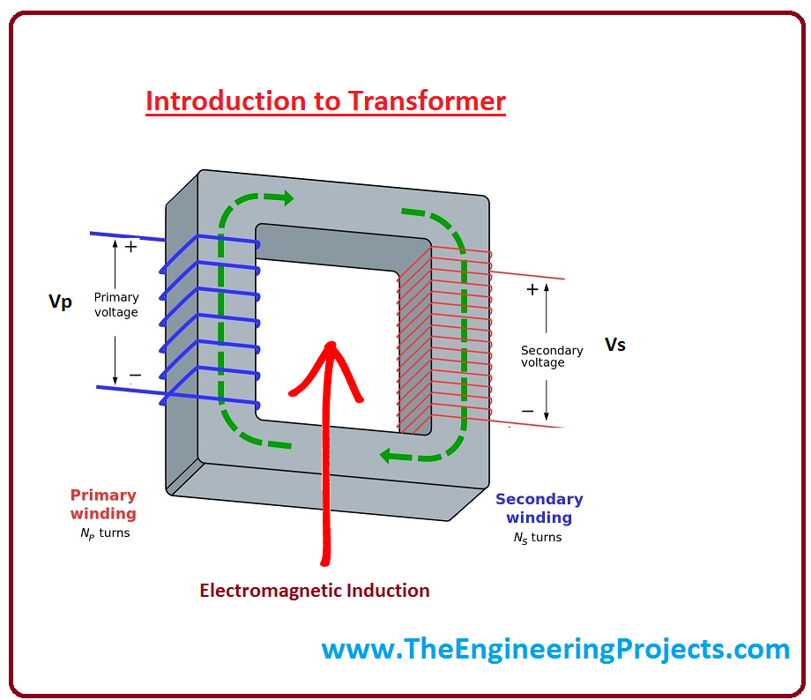

Fig 1.9: Step up transformer

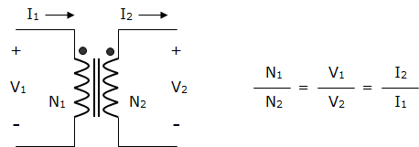

Fig 2.0: Windings in transformer

Working Principle of Step-up Transformer

|  |  |
| --- | --- |
| 1 | When a transformer is used to “increase” the voltage on its secondary winding with respect to the primary, it is called a **Step-up transformer**. |
| 2 | Working of step-up transformer is based on the principle of mutual inductance and it converts the alternating low voltage to alternating high voltage. |
| 3 | The number of turns in the secondary coil is greater than the number of turns in the primary coil. |

Step-down transformer

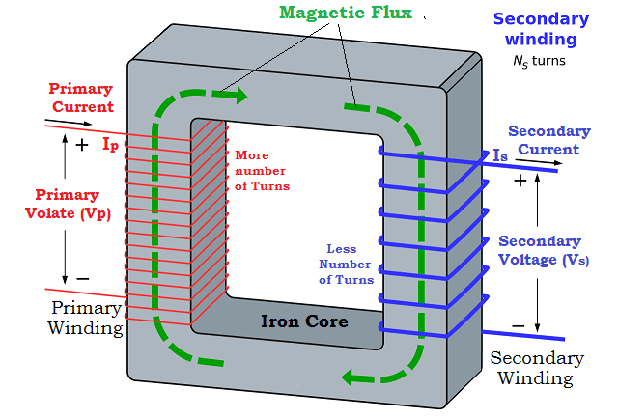

Fig 2.1: Step down transformer

Working Principle of Step-down Transformer

|  |  |
| --- | --- |
| 1 | When a transformer is used to “decrease” the voltage on its secondary winding with respect to the primary, it is called a **Step-down transformer**. |
| 2 | Working of step-down transformer is based on the principle of mutual inductance and it converts the alternating high voltage to alternating low voltage. |
| 3 | The number of turns in the secondary coil is less than the number of turns in the primary coil current. |

### Current transformer

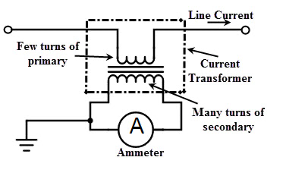

Fig 2.2: Current transformer Circuit

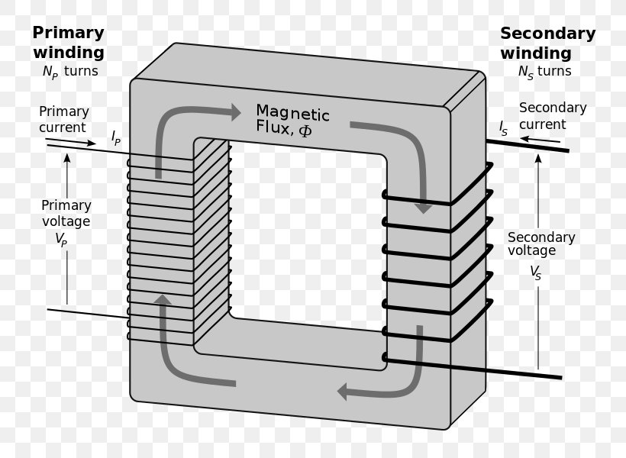

Fig 2.3: Current transformer Windings



Fig 2.4: Windings in transformer

Working Principle of Current Transformer

|  |  |
| --- | --- |
| 1 | A Current Transformer (CT) is used to measure the current of another circuit. |
| 2 | Operational hazards can occur if the secondary circuit of a CT is left open while the primary is energized. | |
| 3 | By knowing the secondary ammeter current and current ratios, we can easily determine the current flowing through the primary which is connected to the main line. | | |

### Potential transformer



Fig 2.5: Potential transformer windings

Working Principle of Potential Transformer

|  |  |
| --- | --- |
| 1 | A Potential Transformer is used to step down primary voltage. |
| 2 | Potential transformer operates on the principles of “Electromagnetic induction”, similar to that of the Transformer. |
| 3 | Primary voltage can be easily stepped down by decreasing the number of windings in the secondary coil. |

### Wattmeter

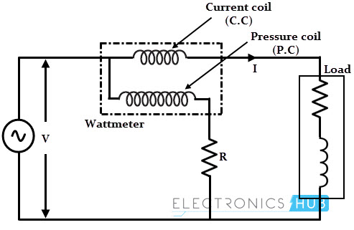

Fig 2.6: Wattmeter Circuit

Working Principle of Wattmeter

|  |  |
| --- | --- |
| 1 | The wattmeter is an instrument for measuring the electric active power (or the average of the rate of flow of electrical energy) in watts of any given circuit. |
| 2 | Current coil is connected in series and potential coil is connected in parallel connection. |
| 3 | When the coil is energized the current drop in current coil and the voltage drop in potential can be easily measured which can be further used to measure power using the formula (P=IV). |

### Voltmeter and Ammeter

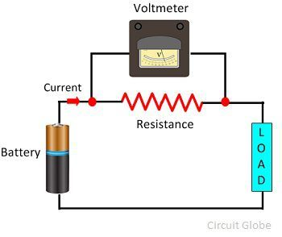

Fig 2.7: Voltmeter in Circuit

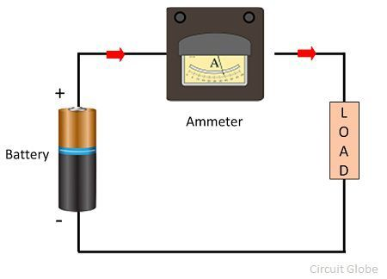

Fig 2.8: Ammeter in Circuit

**Voltmeter Ammeter**

|  |  |  |  |
| --- | --- | --- | --- |
| 1 | A voltmeter is an instrument used for measuring electric potential difference between two points in an electric circuit. | 1 | An ammeter (from ampere meter) is a measuring instrument used to measure the current in a circuit. |
| 2 | Voltmeter is usually connected in parallel with the circuit in which voltage is to be measured. Voltmeter always has high resistance. | 2 | The ammeter is usually connected  in series with the circuit in which  the current is to be measured. It  has low resistance. |
| 3 | The high resistance of the voltmeter does not allow the current to pass through it and thus, the correct reading is obtained. | 3 | The low resistance of the ammeter  allows the current to pass through it and thus, the correct reading is obtained. |

### Self-Induction and Negative Voltage

|  |  |
| --- | --- |
| 1. | 1. When there is a change in the current or magnetic flux of the coil, an opposed induced electromotive force is produced. This phenomenon is termed as Self Induction. 2. When the current starts flowing through the coil at any instant, it is found that the magnetic flux becomes directly proportional to the current passing through the circuit. The relation is given as:   ϕ**= I**  ϕ**= L I**  Where L is termed as self-inductance of the coil or the coefficient of self-inductance, ϕ is the magnetic flux. The self-inductance depends on the cross-sectional area, the permeability of the material, or the number of turns in the coil. |
| 2. | 1. When the supply is connected current is flowing through the windings of the electromagnet coil. 2. This current produces a magnetising field which aligns the magnetic domains in the metal core of the electromagnet. 3. This alignment re-enforces the field making magnetic force greater but also storing a lot more energy in the process.   A picture containing text, device, gauge  Description automatically generated |
| 3. | When the supply is switched off, the magnetic field will tend to collapse and in doing so will generate an EMF or (CEMF) in the electromagnet coil windings known as the back emf or negative voltage.  Diagram  Description automatically generated |
| 4. | 1. Back EMF cannot be prevented but it can be controlled. 2. In suppressing the back EMF, the objective is to prevent the very high voltages and dissipate the stored energy in a controlled way. 3. When the supply voltage is connected the diode is reversed biased and is effectively out of circuit. When the switch opens flywheel current produces a back EMF in the opposite polarity and so the diode will conduct. 4. The diode does a very good job of suppressing the back EMF and clamps the voltage to around a one volt or so.   Diagram  Description automatically generated |

## RELAY WORKING PRINCIPLE

|  |  |
| --- | --- |
| **1** | Initially when the power is not supplied and the relay is in normally open condition, its contact will be opened. When the relay is in normally closed condition, its contact will be closed. |
| 2 | When the coil is energized the armature moves and is connected to the normally opened contact till there exists flow of current through the coil. |
| **3** | When the relay gets energized, that device will be turned on for the appropriate operation. Working principle of the array can be understand from the visuals given in the figure shown below.  Diagram, schematic  Description automatically generated |

## PROTECTIVE RELAY

|  |  |
| --- | --- |
| 1 | A protective relay is a switchgear device that detects the fault and initiates the operation of the circuit breaker to isolate the defective element from the rest of the system. |
| 2 | Protective relays detect the abnormal conditions in the electrical circuits by constantly measuring the electrical quantities which are different under normal and fault conditions. |
| 3 | The electrical quantities which may change under fault conditions are voltage, current, frequency, and phase angle. |
| 4 | Through the changes in one or more of these quantities, the faults signal their presence, type, and location to the protective relays. |
| 5 | Having detected the fault, the relay operates to close the trip circuit of the breaker. This results in the opening of the breaker and disconnection of the faulty circuit. |



Fig 2.9: Protective Relay before Trip coil got tripped from Circuit Breaker

Operation of Protective Relay

|  |  |  |
| --- | --- | --- |
| 1 | When a short circuit occurs at point F on the transmission line, the current flowing in the line increases to an enormous value. | |
| 2 | This results in a heavy current flow through the relay coil, causing the relay to operate by closing its contacts. | |
| 3 | | In turn, closes the trip circuit of the breaker, making the circuit breaker open and isolating the faulty section from the rest of the system. |
| 4 | | This way, the relay ensures the safety of the circuit equipment from damage and normal working of the healthy portion of the system. |



Fig 3.0: Protective Relay after Trip coil got tripped from Circuit Breaker

## INTERFACING RELAY WITH MICROPROCESSOR

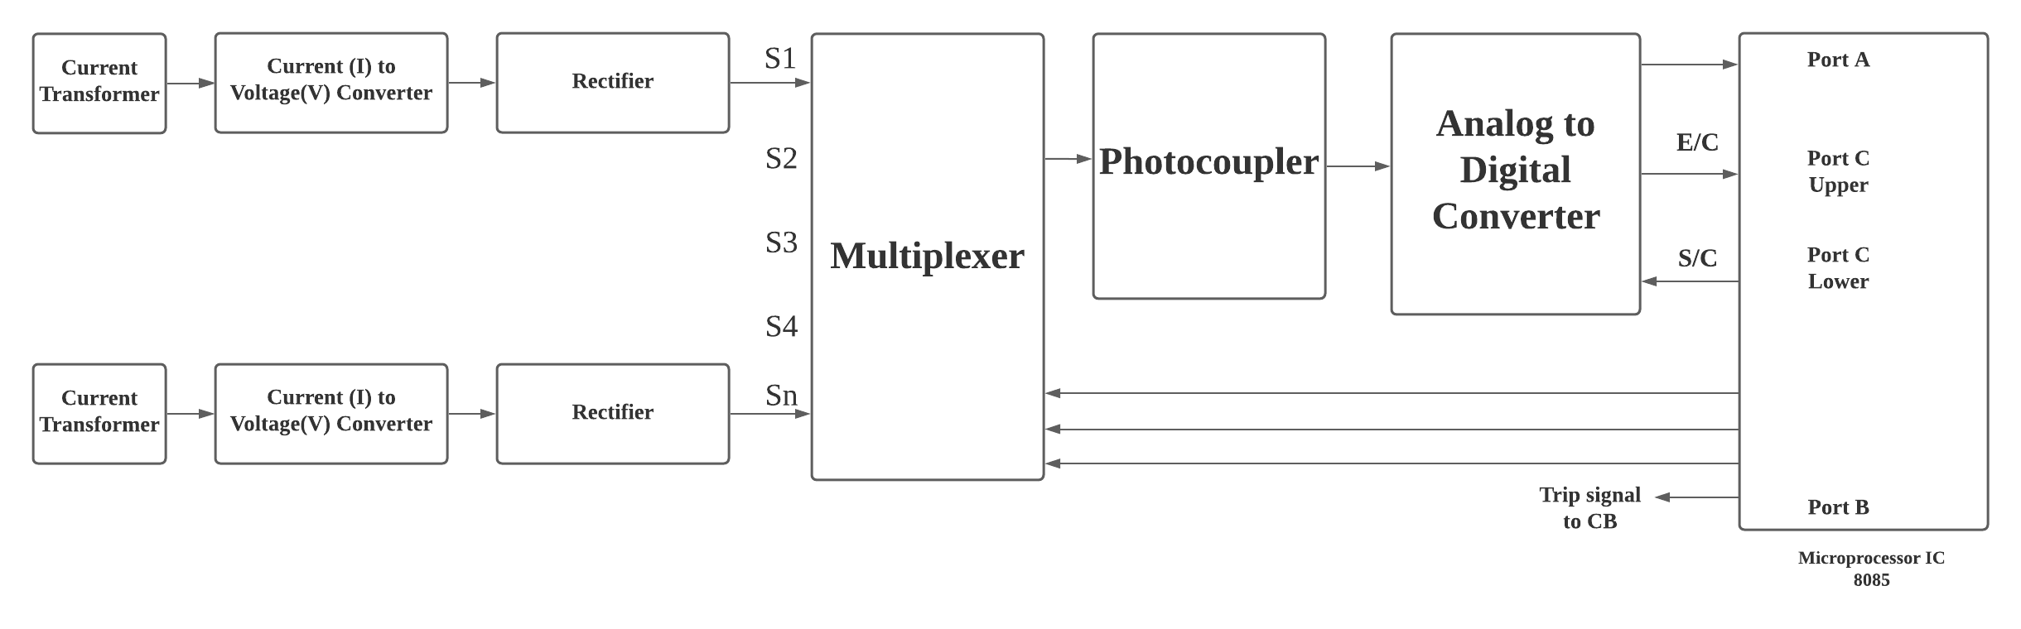 Fig 3.1: Block diagram of Relay interfacing with Microprocessor

**Description of the Block Diagram**

|  |  |
| --- | --- |
| 1 | As the microprocessor accepts signals in voltage form, the current signal derived from the current transformer is converted into a proportional voltage signal using a current to voltage converter. |
| 2 | The ac voltage proportional to the load current is converted into dc using a precision rectifier. |
| 3 | The microprocessor accepts signals in digital form. Therefore, analog signals must be converted into digital form before  feeding them to the microprocessor for processing. |
| 4 | An A/D converter is used to convert analog signals into digital  forms. If more than one analog quantity is to be converted into digital form by using only one A/D converter, analog multiplexers are used to select any one analog quantity at a time for A/Conversion. |
| 5 | The Multiplexer gives output to A/D Converter where Analog DC voltage is converted to Digital form (in form of O and 1 i.e., binary form). Microprocessor understands only codes in 0 and 1 form. |

## INTERFACING CIRCUIT OF RELAY WITH MICROPROCESSOR



Fig 3.2: Interfacing Circuit of Relay with Microprocessor

**Description of the above Interfacing Circuit**

|  |  |
| --- | --- |
| 1 | A relay should not be directly connected to a microcontroller, it needs a driving circuit. |
| 2 | 1. A microcontroller is not able to supply current required for the working of a relay. 2. The maximum current that a PICMicrocontroller can source, or sink is 25mA while a relay needs about 50 – 100mA current. 3. The Port no. 21 (5V) of the Microcontroller should not be directly connected to the Relay. 4. As the Relay doesn’t operate until its voltage is rated at 12V or higher. So, the Relay must be supplied with 12V separate voltage. 5. Relay won’t operate if it is directly connected to Port no.21(5V) supply. |
| 3 | A relay is activated by energizing its coil. Microcontroller may stop working by the negative voltages produced in the relay due to its back emf. Negative voltage is caused due to the phenomenon called “Self-Induction “. |
| 4 | Transistor is used as a switch which carries the current required for operation of the relay. |
| 5 | **When the pin P2.0 of the microcontroller goes high, i.e. if logic 1 is send from the port P2.0 of the microcontroller:**   1. The NPN transistor turns ON as NPN transistors always turn ON while giving 1 to base. 2. When the NPN transistor turns ON it connects the terminal 2 of the Relay coil to the Ground. 3. Relay gets supplied with 12V and the coil of Relay gets energized. 4. As a result, the COM terminal of Relay breaks from the NC and connects to NO terminal. It turns ON the relay switch.   **When the pin P2.0 of the microcontroller goes low, i.e. if logic 0 is send from the port P2.0 of the microcontroller**:   1. The NPN transistor turns OFF as NPN transistors always turn OFF while giving 0 to base. 2. When the NPN transistor turns OFF it disconnects the terminal 2 of the Relay coil to the Ground. As a result, the circuit doesn’t get completed. 3. Relay doesn’t get supplied with 12V and the coil of Relay gets deenergized. 4. As a result, the COM terminal of Relay breaks from the NO and connects to the NC terminal. It turns OFF the relay switch. |
| 6 | 1. Relay doesn’t operate until its voltage is rated at 12V or higher. 2. Diode is used for increasing the voltage between the “5-2” terminal of the diagram. Without using the diode during closed circuit, the +12V power supply divides and the relay won’t be operated at +12V. 3. Hence diodes are used to prevent the circuit from the splitting of power supply. |
| 7 | 1. Transistor can be replaced by a normal switch as well in the above circuit. 2. Relay will turn ON while Swich is in ON state, and Relay will turn OFF when Switch is in OFF state. 3. In the case of using Normal Switch, control can’t be done using a Microprocessor. In the case of normal switch”   Incoming Current (Ic) = Outgoing Current (IE).   1. Diode is still needed to prevent the Voltage splitting and provide regular supply of 12V supply to Relay. |

## BACnet COMMUNICATION PROTOCOL

* BACnet (Building Automation and Control Network) is a communications protocol that defines the services used to communicate between building automation end-devices and building control systems.
* The BACnet protocol specification, like all protocol specification defines both how data is represented on the network and the services that are used to move data from one BACnet node to another.
* BACnet Communication Protocol also includes messages that identify data and network nodes.
* BACnet offers a flexible range of networking options including the use of Ethernet or IP-centric infrastructure and a simple, low cost twisted pair communication called MS/TP that is based on EIA485.
* A sophisticated routing capability allows scaling of BACnet internetworks into large and efficient systems, all within the same unified standard.
* Hence, SEL Relays can be connected in the AMPS system using BACnet Communication Protocol.

### BACnet Features

* BACnet Features refers to those services, which are formal requests that one BACnet device sends to another BACnet device to ask it to do something.
* Services are grouped into five categories of functionality:

1. Object access (read, write, create, delete)
2. Device management (discover, time synchronization, initialize, backup and restore database)
3. Alarm and event (alarms and changes of state)
4. File transfer (trend data, program transfer)
5. Virtual terminal (human machine interface via prompts and menus).

* BACnet devices exchange information and do things by sending and receiving electronic messages containing this coded language.
* BACnet provides flexibility by allowing multiple types of transport systems to be used to convey these coded messages between devices.

### BACnet Applications

1. Data Sharing

* Data Sharing is the exchange of information between BACnet devices. It may be uni-directional or bidirectional.
* In Data Sharing, a client device requests data from a server device, and may also send control commands to the server.
* Typical Data Sharing requests that a client will make to a server are ReadProperty and WriteProperty.

1. Trending

* Trending allows BACnet devices to enable trend collection and request trend data from other BACnet devices

1. Scheduling

* Scheduling allows BACnet devices to establish and edit schedules that reside in BACnet devices so that control can be coordinated based on dates and times.

1. Alarm & Event Management

* Alarm & Event Management defines the exchange of data based on pre-defined alarm limits or event triggers.
* The event or alarm may require human intervention and acknowledgement.

1. Device & Network Management

* Device & Network Management allows BACnet devices to discover other BACnet devices, discover objects within devices, establish and re-establish communications, synchronize time, and re-initialize a device’s program.

### BACnet Network Types and Architecture

1. BACnet MS/TP

* This LAN type uses EIA-485 twisted pair for signalling up to 4000 feet.
* It is the most popular type of BACnet LAN for unitary and application-specific controllers and is also the lowest cost.

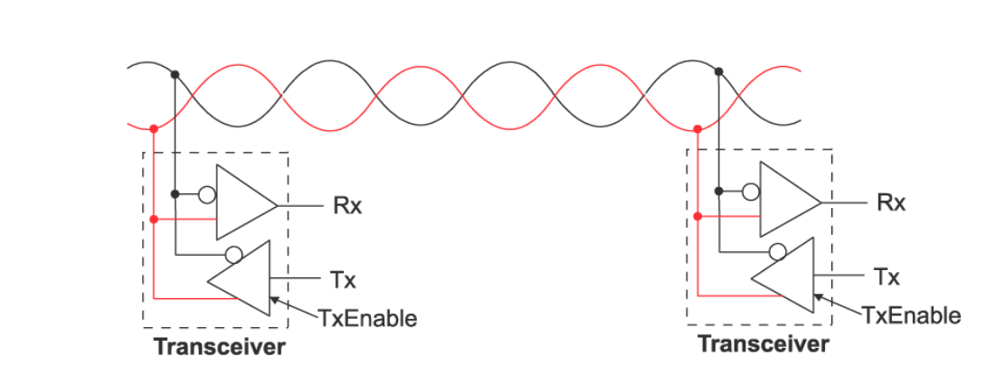

supported by BACnet

1. BACnet ISO 8802-3 (Ethernet)

* BACnet can be used directly with Ethernet 8802-3 networks.
* This MAC type is comparable to BACnet/IP in terms of cost and speed but limited to a single physical infrastructure that does not make use of IP routers.

1. BACnet over ARCNET

* This MAC type has two forms: 2.5Mbs coax, and 156Kbs over EIA-485.
* The ARC156K form has a modest increase in performance compared to MS/TP for a slight cost difference.
* A limited number of vendors support BACnet using ARCNET.

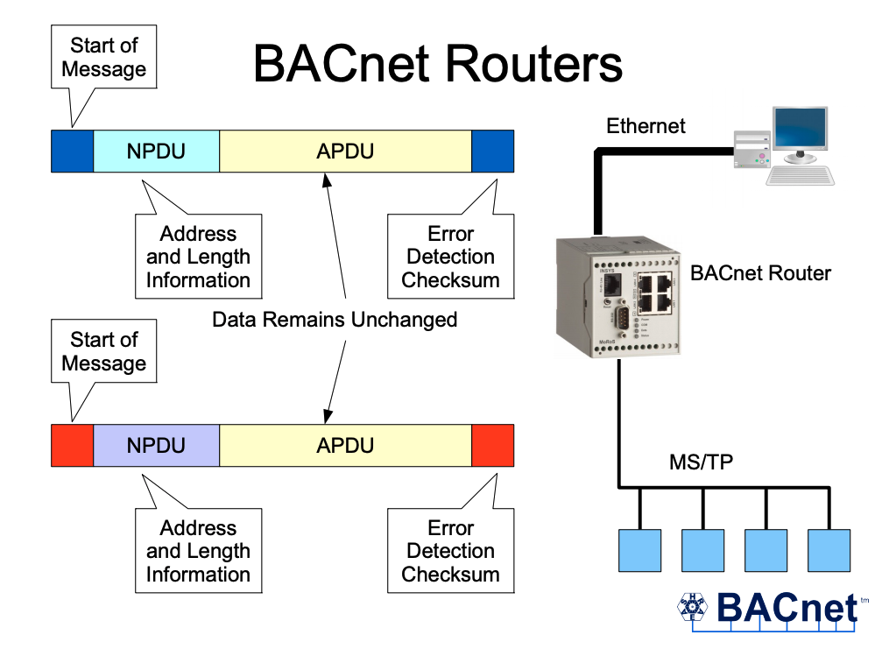

Fig 3.3: BACnet Communication Networks

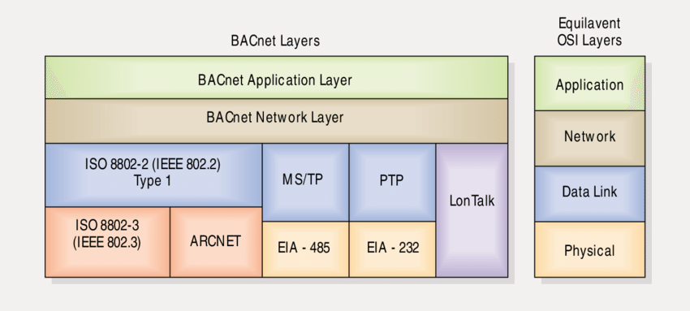

Fig 3.4: BACnet Network Architecture Diagram

## THREE PHASE AC POWER

### SINGLE-PHASE AC POWER SUPPLY

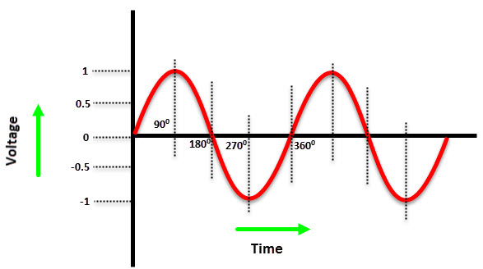

Fig 3.5: Single Phase AC Sine Wave

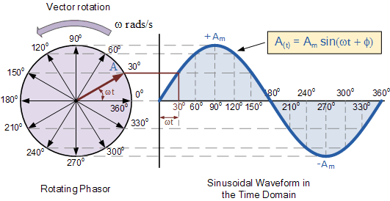

Fig 3.6: Single Phase AC Phasor diagram

* In a Single-Phase Power Supply, the power is distributed using only two wires called Phase and neutral.
* The phase wire carries the current to the load and the neutral wire provides the return path of the current.
* Usually, the single-phase voltage is 230V and the frequency is 50Hz (this depends on the location).
* Depending on the region, a single-phase supply is sufficient for loads up to 2500 Watts.
* Small single-phase motors (usually less than 1kW) cannot start directly with the help of a single-phase supply as there isn’t sufficient initial torque for the motor. So, additional circuitry like a Motor Starters (like a starter capacitor in fans and pumps) are needed for proper operation.

### THREE-PHASE AC POWER SUPPLY

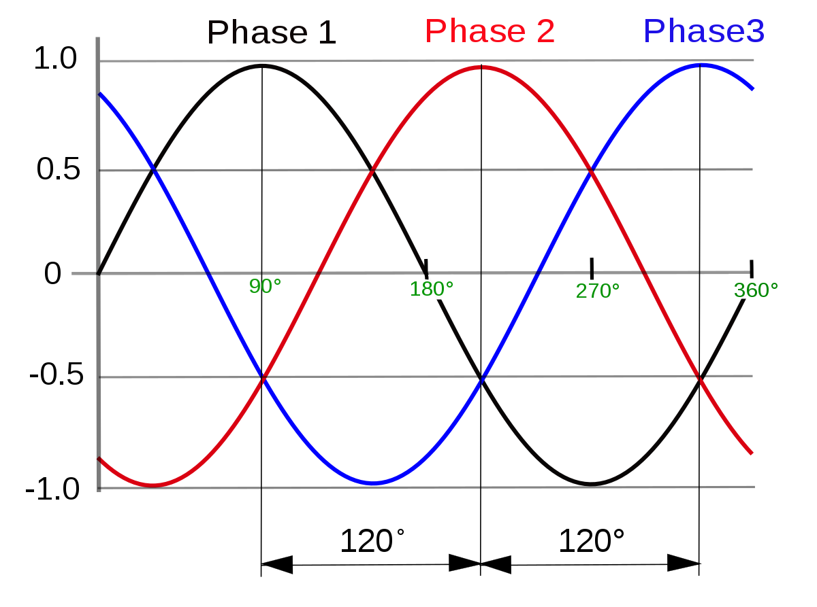

Fig 3.7: Three Phase AC Sine Wave

* A Three Phase Power Supply consists of three power wires (or the three phases). Additionally, depending on the type of the circuit (which there are two types: Star and Delta), you might or might not have a neutral wire.
* In a three-phase power supply system, each AC Power Signal is 1200 out of phase with each other.

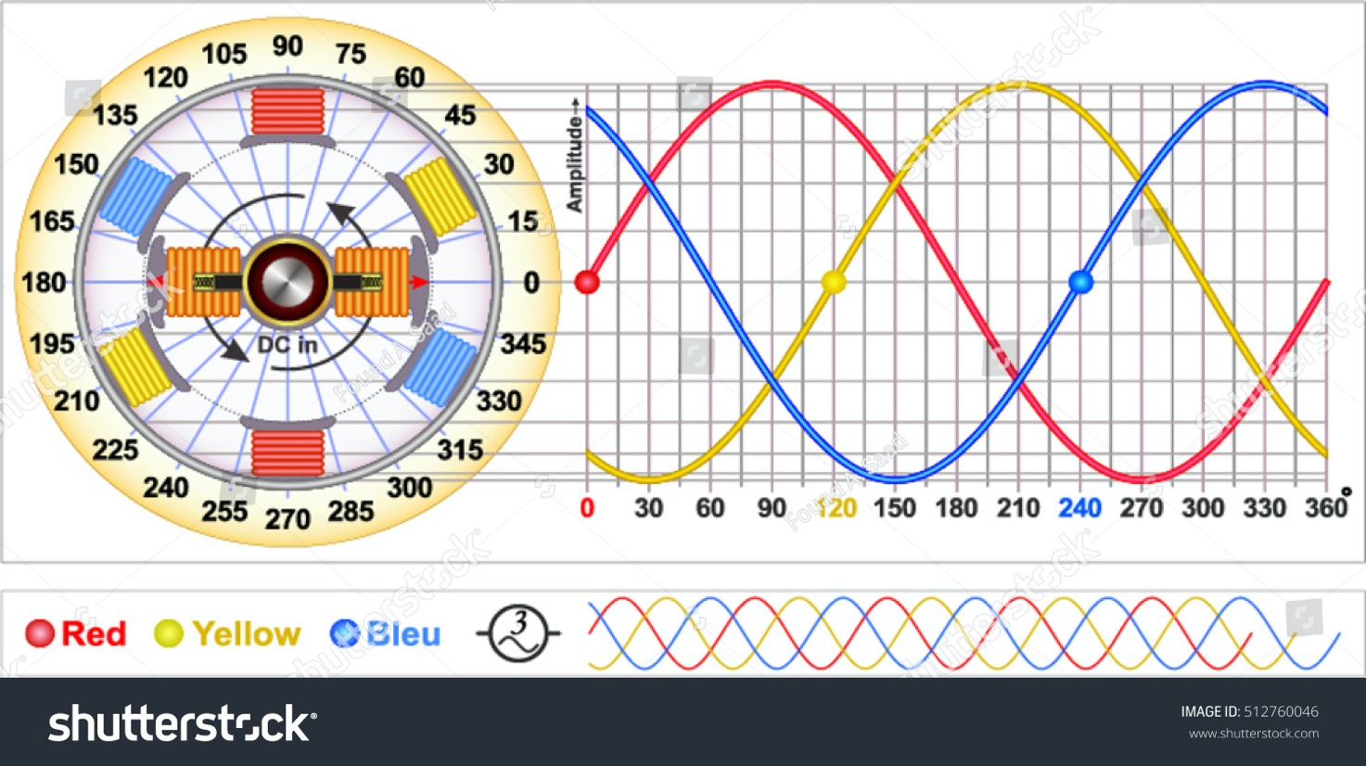

Fig 3.8: Three Phase AC Phasor diagram

* In a three-phase power supply, during one cycle of 3600, each phase would have peaked in voltage twice. Also, the power never drops to zero. This steady stream of power and ability to handle higher loads makes a three-phase supply suitable for industrial and commercial operations.
* For the same power, a three-phase power supply uses less wire than a single-phase power supply.
* Large three phase motors (usually used in industries) do not require a starter as the phase difference in the three-phase power supply will be sufficient to provide enough initial torque for the motor to start.
* The overall efficiency of the three-phase power supply is higher when compared to that of a single-phase power supply for the same load.

### BALANCED THREE PHASE CIRCUIT

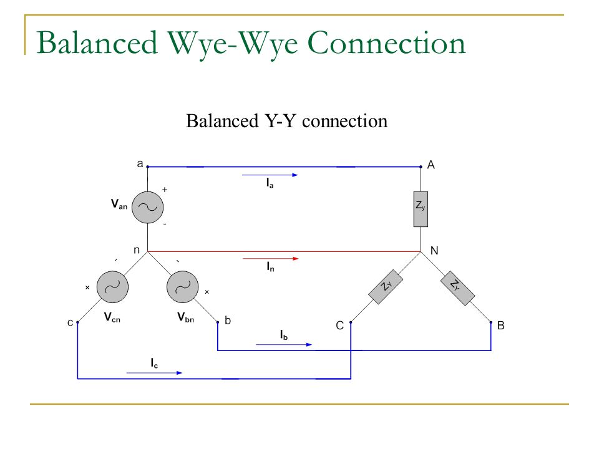

* When the load of each phase is equal, it is called balanced load.
* A circuit in which the power supply is a symmetrical three-phase alternating current and the load side is a balanced load is called a balanced three-phase circuit.

### Y-Y CONNECTION THREE PHASE CIRCUIT



**Y-Y connection**

**Line voltage = √3 x phase voltage**

**Line current = phase current**

* In YY connection, the transmission current is the same as the line current, but the line voltage is √3 times the phase voltage.

### Δ-Δ CONNECTION THREE PHASE CIRCUIT

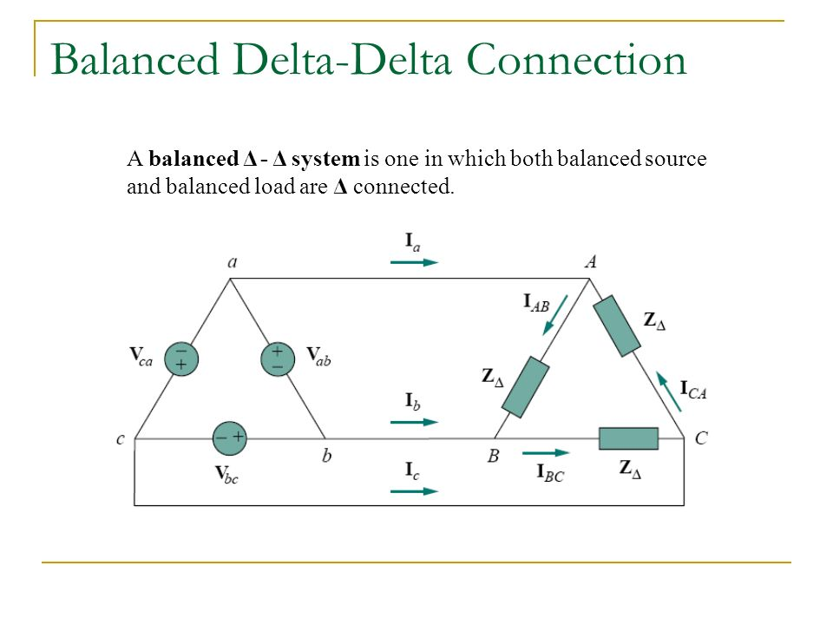

**In Δ-Δ Connection**

**Line voltage = Phase voltage**

**Line current = √3 x Phase current**

### V- Δ CONNECTION THREE PHASE CIRCUIT

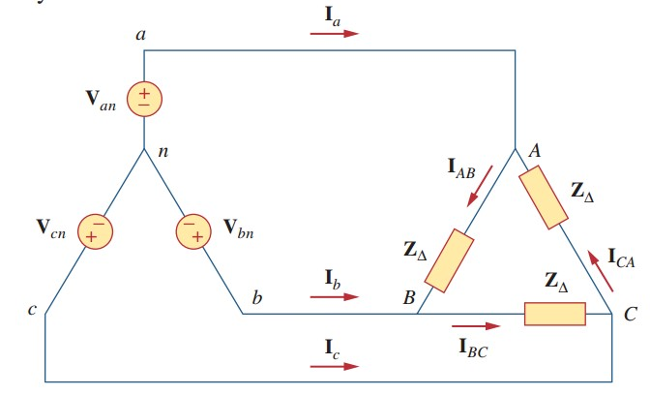

V-connection

**voltage = phase voltage** (symmetrical three-phase AC)

* V-connection transformer utilization rate Connectable load capacity / capacity for two transformers= (√3) / 2 = 86.6% When the same power supply is used Capacity of V connection with respect to Δ connection = 1 / (√3) = 57.7%
* Line current of V-Δ connection in V-Δ connection, phase voltage = line voltage (however, a phase without a power supply is the opposite of the sum of other phase voltages.)

### Δ -Y/ Y- Δ CONVERSION LOAD CIRCUIT

**Delta to wye conversion formulas**

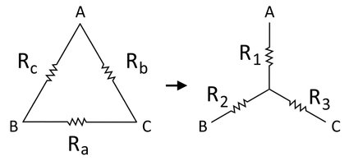

R1 = (Rb * Rc)/(Ra + Rb + Rc)

R2 = (Rc * Ra)/(Ra + Rb + Rc)

R3 = (Ra * Rb)/(Ra + Rb + Rc)

Where,

* Ra, Rb, Rc are the resistances in the delta network.
* R1, R2, R3 are the resistances in the wye network.

**Wye to delta conversion formulas**

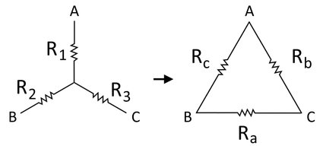

Ra = R2 + R3 + (R2 * R3 / R1)

Rb = R3 + R1 + (R3 * R1 / R2)

Rc = R1 + R2 + (R1 * R2 / R3)

where,

• Ra, Rb, Rc are the resistances in the delta network,

• R1, R2, R3 are the resistances in the wye network.

## LINEAR POWER GENERATOR

* It is the device that follows direct conversion of linear motion into electricity.
* High expansion allows for maximum extraction of reaction energy and direct conversion eliminates mechanical losses and combines to enable high efficiency operation.

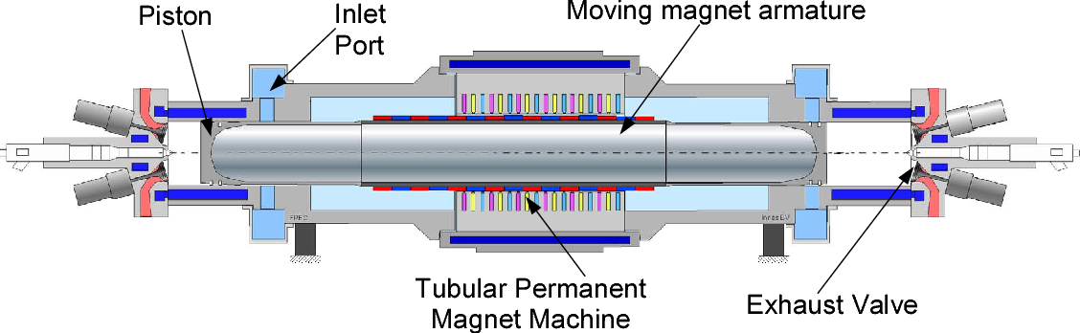

Fig 3.9: Linear Permanent Magnet Generator

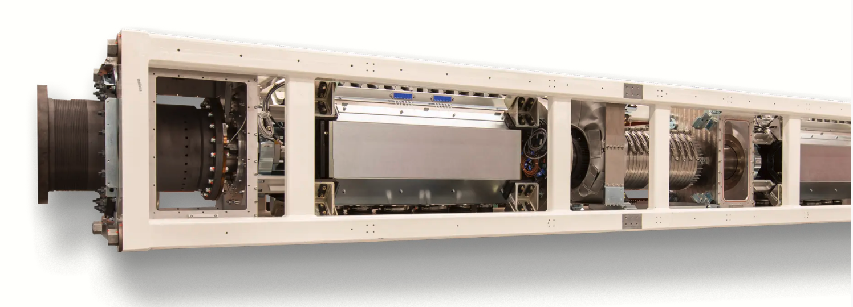

Fig 4.0: Linear Power Generator

**Linear Generator Features**

1. High Efficiency

* Mainspring’s linear generator is designed to enable high expansion of reacted gases and to electrically control the conversion of linear motion directly into electricity.
* As the high expansion gives maximum extraction of energy, linear generator has very high efficiency of operation.

1. Fuel Flexible

* Mainspring’s linear generator technology continuously adjusts compression and expansion, allowing it to dynamically adjust for varying fuel quality and different types of fuels, including renewable biogas and hydrogen.

1. Low Capital & Maintenance Costs

* Mainspring’s linear generator is made out of standard materials with only two moving parts and operates without the use of oil or expensive fuel cell catalysts or complex engine mechanical systems, resulting in low capital and maintenance costs.

1. Near-Zero NOx Emissions

* Mainspring’s linear generator uses a low-temperature, uniform reaction that maintains peak temperatures below the levels in which NOx forms (1500°C), resulting in near-zero NOx emissions.

1. Fully Dispatchable

* Mainspring’s linear generators match power output with building demand while integrating with onsite solar and energy storage, enabling the continued rapid adoption of renewables.
* In addition, Mainspring’s technology provides power when the grid is down, making it the ideal backbone of any renewable microgrid.

1. Turn-Key Packaging

* Mainspring’s linear generator products combine grid-tie inverters and auxiliaries into turn-key packages for fast and simple installation.
* Mainspring’s first product is designed for commercial businesses with a rated output of 240 kW net AC (3-phase, 480 V) and packaged in a standard 20’ container.

## SERIAL/ETHERNET BOUND RATE AND MIPS

**Serial Baud Rate**

* The baud rate specifies how fast data is sent over a line. It's usually expressed in units of bits-per-second (bps).
* One of the more common baud rates, especially for simple stuff where speed isn't critical, is 9600 bps. Other "standard" baud are 1200, 2400, 4800, 19200, 38400, 57600, and 115200.
* The higher a baud rate goes, the faster data is sent/received, but there are limits to how fast data can be transferred.
* In the serial port context, "9600 baud" means that the serial port can transfer a maximum of 9600 bits per second.

**Serial Port:**

Baud Rate = 2400 BPS

Data Bits = 8

Parity = N

Stop Bits = 1

**Ethernet Port:**

Baud Rate = 100 MBPS

* Bit rate is not used to decide the requirement of bandwidth for transmission of signal. While baud rate is used to decide the requirement of bandwidth for transmission of signal.
* The formula which relates both bit rate and baud rate is given below:

**Bit rate = Baud rate x the number of bits per baud.**

**Data Bus Devices and Baud Rate**

**The BACnet MS/TP data bus supports up to 255 devices:**

* Up to 128 (0 to 127) devices that are Masters (that can initiate communication)
* Up to 128 (128 to 255) devices that are Slaves (cannot initiate communication)

**MIPS (Millions of instructions per second)**

* Divide the number of instructions by the execution time.
* Divide this number by 1 million to find the millions of instructions per second.
* Alternatively, divide the number of cycles per second (CPU) by the number of cycles per instruction (CPI) and then divide by 1 million to find the MIPS.
* Unlike clock rate, MIPS provides some idea of the work performed.
* However, even MIPS is not a good indication of performance because not all instructions perform the same amount of computation.

## REAL TIME LINUX OPERATING SYSTEM

* **LINUX** is different from Windows and Apple in that it’s not a proprietary software, but rather a family of open-source systems. In other words, anyone can modify and distribute it.
* Linux may be the least known on this list, but it’s free and available in many different open-source versions.
* Linux is popular because of its ease of customization and offers a variety of options to those who understand how to use it.

**RT Linux**

* RT-Linux provides the capability of running special real-time tasks and interrupt handlers on the same machine as standard Linux. These tasks and handlers execute when they need to execute no matter what Linux is doing.
* Real-time Linux operates on a Linux system; the real-time kernel is placed between the Linux system and the hardware. All interrupts generated by the hardware are intercepted by the real-time Linux kernel.
* However, hardware interrupts are not associated with the [real-time system](https://www.intervalzero.com/real-time-operating-system-rtos/) activities but are held and passed to the Linux kernel as software interrupts when the standard Linux kernel is running and the real-time Linux is idle.

**Real Time Linux Features**

* The Runtime System
* Real-time Preservation
* Development Environment
* C/C++ Runtime Library, Drivers, Third-Party Software
* Popularity, Flexibility, and Portability
* Frequency-based scheduling
* Embedded target configuration tool

# **Conclusion**

Hence, the automatic protection system can be developed using Protective Relays, Instrument Transformer, Revenue meter, Microprocessor which supports comprehensive testing of the existing protection system. Thus, developed system will be able to perform all functions without the access to the internet. The AMPS system provides the interface options with a network connected computer or internet-based system.

Self-monitoring of the electrical quantities by the microprocessor automatised the system. Receiving the signals continuously, monitoring those signals and saving the information in the file at the same time makes the function multitasking. Any kind of abnormal conditions can be easily detected and can be isolated from the system. Real time version of Linux Operating system can be used in AMPS system which manages system hardware, software resources, and provides common services in the system.

Thus, in this way automatic maintenance of Protection system can be developed. While the device will be used for the protection system, it could be used with PV, Wind, natural gas, and other industrial applications.

***